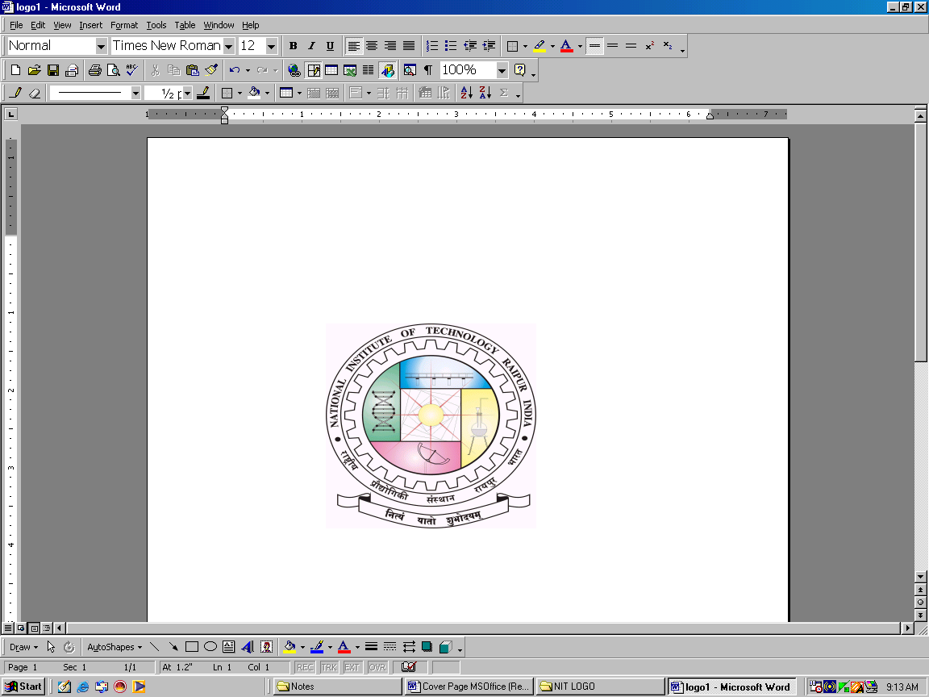
Department of Chemical Engineering
Phone: (0771) 2254200
Fax: (0771) 2254600
Email: hod.che@nitrr.ac.in
Website: www.nitrr.ac.in
National Institute of Technology Raipur
(An Institute of National Importance)
G.E. Road, Raipur - 492010 (C.G)

RECORD OF MENTORSHIP
Details of the Student
1 | Name of the Student:
2 | Roll No. & Enrollment No:
3 | Student’s Mobile No:
4 | Student’s Email Address:
5 | Postal Address:
6 | Father’s Name & Contact No:
7 | Mother’s Name & Contact No:
8 | Admission Year:
9 | Year of Mentorship & Semester:

I certify that all information mentioned above is correct to the best of my knowledge

Date: ______________ Student Signature:____________________________

Details of the Mentor
1 | Name of the Mentor:
2 | Designation:
3 | Address: | Department of Chemical Engineering  NIT Raipur, GE Road, Raipur.
4 | Mobile No:
5 | Email Address:
6 | Year of Mentorship & Semester:

Name of the Student:
Meeting Date | Issues Discussed | Suggestions to the student | Signature of the candidate | Signature of the Mentor | Remarks  (If any)

